SSL/TLS certificate
# Source: AI Source: Provided by: [Data Path: Persons Table -> ID Column: 1, Name_En Column: Motasem Essam] -> From: [ChatGPT] on [1/18/2026]
An SSL/TLS certificate is a type of digital certificate used to secure communication over a network by encrypting data and verifying the identity of a server (and sometimes a client). It’s what makes HTTPS possible.
🔎 SSL is the old name; TLS is the modern, secure version—but people still say “SSL certificate.”

🔐 What an SSL/TLS Certificate Does
# Source: AI Source: Provided by: [Data Path: Persons Table -> ID Column: 1, Name_En Column: Motasem Essam] -> From: [ChatGPT] on [1/18/2026]
It provides three key security functions:
- Encryption – protects data from eavesdropping
- Authentication – proves the server is who it claims to be
- Integrity – ensures data isn’t modified in transit

📄 What’s Inside an SSL/TLS Certificate
# Source: AI Source: Provided by: [Data Path: Persons Table -> ID Column: 1, Name_En Column: Motasem Essam] -> From: [ChatGPT] on [1/18/2026]
- Domain name (e.g., example.com)
- Public key
- Certificate Authority (CA)
- Validity period (start & expiry)
- Digital signature from the CA
Example (PEM format)
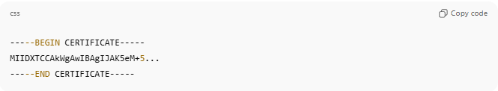
-----BEGIN CERTIFICATE-----
MIIDXTCCAkWgAwIBAgIJAK5eM+5...
-----END CERTIFICATE-----

🛠️ How It Works (HTTPS Example)
# Source: AI Source: Provided by: [Data Path: Persons Table -> ID Column: 1, Name_En Column: Motasem Essam] -> From: [ChatGPT] on [1/18/2026]
- Browser connects to https://example.com
- Server sends its SSL/TLS certificate
- Browser verifies the certificate using trusted CA
- Browser and server agree on encryption keys
- Secure, encrypted communication begins 🔒

📍 Where SSL/TLS Certificates Are Used
# Source: AI Source: Provided by: [Data Path: Persons Table -> ID Column: 1, Name_En Column: Motasem Essam] -> From: [ChatGPT] on [1/18/2026]
- Websites (HTTPS)
- APIs
- Databases (encrypted DB connections)
- Email servers (SMTP, IMAP)
- VPNs
- Microservices

🧠 Types of SSL/TLS Certificates
# Source: AI Source: Provided by: [Data Path: Persons Table -> ID Column: 1, Name_En Column: Motasem Essam] -> From: [ChatGPT] on [1/18/2026]
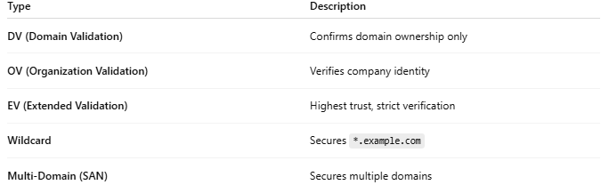
Type | Description
DV (Domain Validation) | Confirms domain ownership only
OV (Organization Validation) | Verifies company identity
EV (Extended Validation) | Highest trust, strict verification
Wildcard | Secures *.example.com
Multi-Domain (SAN) | Secures multiple domains
complete visual cheat sheet of all SSL/TLS certificate types
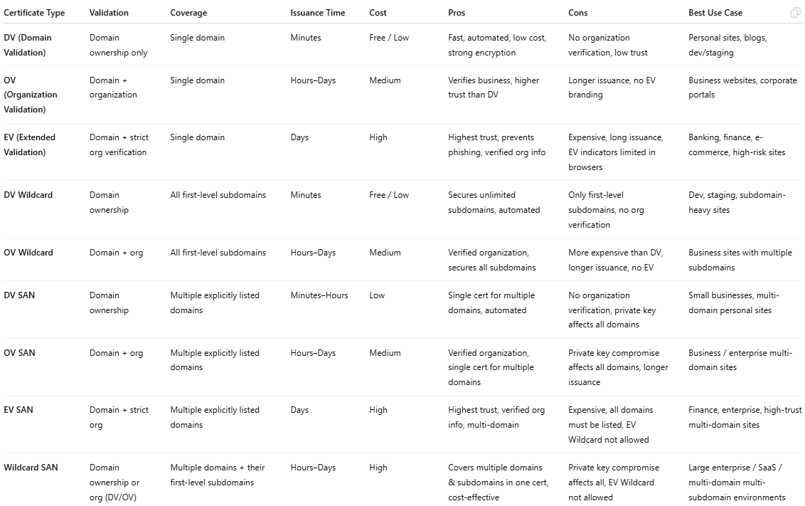
Certificate Type | Validation | Coverage | Issuance Time | Cost | Pros | Cons | Best Use Case
DV (Domain Validation) | Domain ownership only | Single domain | Minutes | Free / Low | Fast, automated, low cost, strong encryption | No organization verification, low trust | Personal sites, blogs, dev/staging
OV (Organization Validation) | Domain + organization | Single domain | Hours–Days | Medium | Verifies business, higher trust than DV | Longer issuance, no EV branding | Business websites, corporate portals
EV (Extended Validation) | Domain + strict org verification | Single domain | Days | High | Highest trust, prevents phishing, verified org info | Expensive, long issuance, EV indicators limited in browsers | Banking, finance, e-commerce, high-risk sites
DV Wildcard | Domain ownership | All first-level subdomains | Minutes | Free / Low | Secures unlimited subdomains, automated | Only first-level subdomains, no org verification | Dev, staging, subdomain-heavy sites
OV Wildcard | Domain + org | All first-level subdomains | Hours–Days | Medium | Verified organization, secures all subdomains | More expensive than DV, longer issuance, no EV | Business sites with multiple subdomains
DV SAN | Domain ownership | Multiple explicitly listed domains | Minutes–Hours | Low | Single cert for multiple domains, automated | No organization verification, private key affects all domains | Small businesses, multi-domain personal sites
OV SAN | Domain + org | Multiple explicitly listed domains | Hours–Days | Medium | Verified organization, single cert for multiple domains | Private key compromise affects all domains, longer issuance | Business / enterprise multi-domain sites
EV SAN | Domain + strict org | Multiple explicitly listed domains | Days | High | Highest trust, verified org info, multi-domain | Expensive, all domains must be listed, EV Wildcard not allowed | Finance, enterprise, high-trust multi-domain sites
Wildcard SAN | Domain ownership or org (DV/OV) | Multiple domains + their first-level subdomains | Hours–Days | High | Covers multiple domains & subdomains in one cert, cost-effective | Private key compromise affects all, EV Wildcard not allowed | Large enterprise / SaaS / multi-domain multi-subdomain environments

✅ Advantages
# Source: AI Source: Provided by: [Data Path: Persons Table -> ID Column: 1, Name_En Column: Motasem Essam] -> From: [ChatGPT] on [1/18/2026]
- Encrypts sensitive data
- Builds trust with users
- Required for modern browsers & APIs
- Improves SEO and compliance

⚠️ Common Issues
# Source: AI Source: Provided by: [Data Path: Persons Table -> ID Column: 1, Name_En Column: Motasem Essam] -> From: [ChatGPT] on [1/18/2026]
- Expired certificates → browser warnings 🚨
- Misconfigured TLS versions or ciphers
- Private key exposure
- Using self-signed certs in production

🔒 Best Practices
# Source: AI Source: Provided by: [Data Path: Persons Table -> ID Column: 1, Name_En Column: Motasem Essam] -> From: [ChatGPT] on [1/18/2026]
- Use TLS 1.2 or TLS 1.3
- Protect the private key
- Enable automatic certificate renewal
- Use trusted CAs (Let’s Encrypt, DigiCert, etc.)
- Disable weak ciphers and old protocols

🧠 Authentication Factor
# Source: AI Source: Provided by: [Data Path: Persons Table -> ID Column: 1, Name_En Column: Motasem Essam] -> From: [ChatGPT] on [1/18/2026]
- Something you have → server certificate + private key

One-sentence summary
# Source: AI Source: Provided by: [Data Path: Persons Table -> ID Column: 1, Name_En Column: Motasem Essam] -> From: [ChatGPT] on [1/18/2026]
An SSL/TLS certificate encrypts data and proves a server’s identity so communication over the internet is private and trusted.

